**Navigating the Undergraduate Research Portal for Faculty**

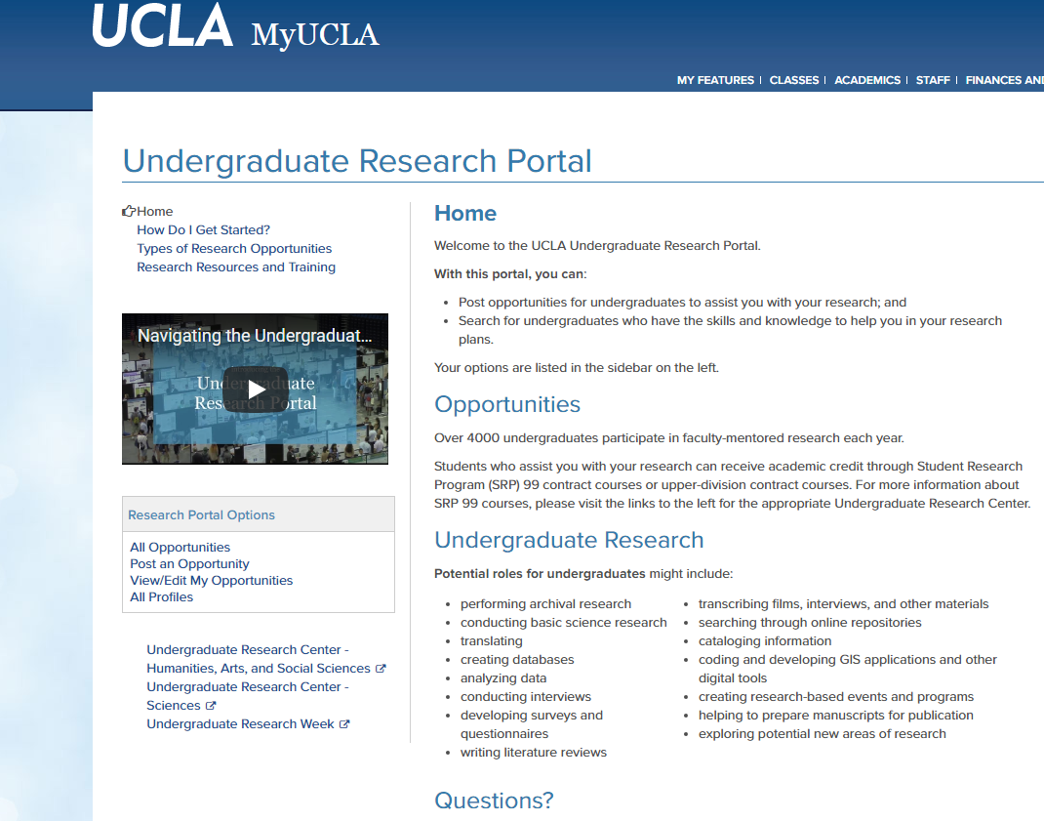

Online instructions on how to use the Portal

Instructional video on how to use the Portal

Link to post an opportunity

1. This should take you to the Portal homepage, which describes the Portal and offers links to various information.
2. Select “Post an opportunity”.

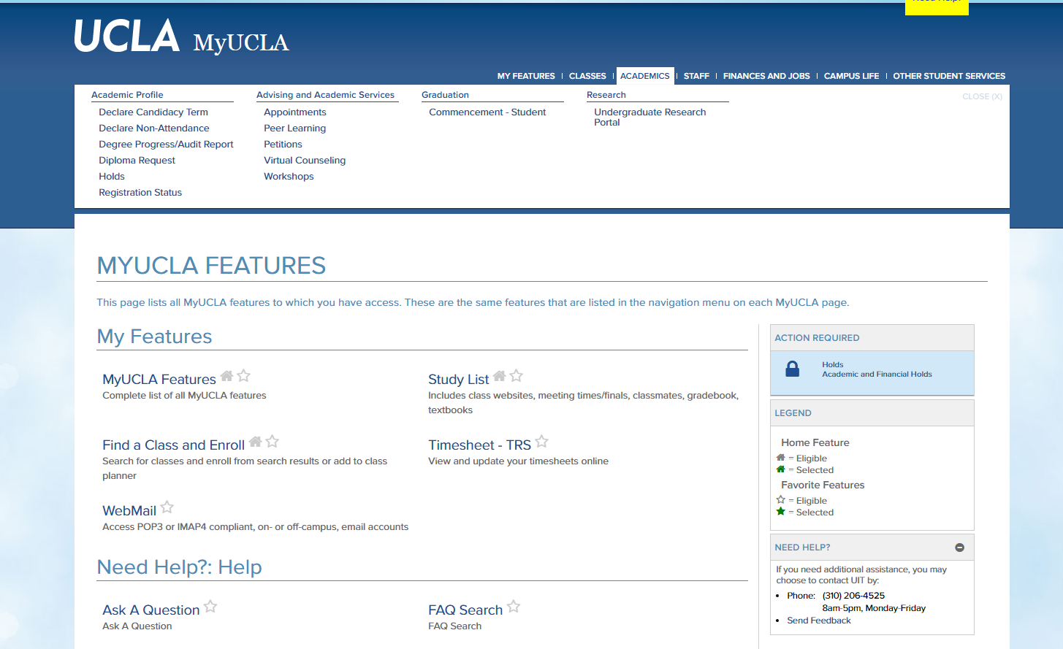

1. Log in to MyUCLA and select the “Academics” tab at the top of the homepage.
2. Under research, select the “Undergraduate Research Portal”

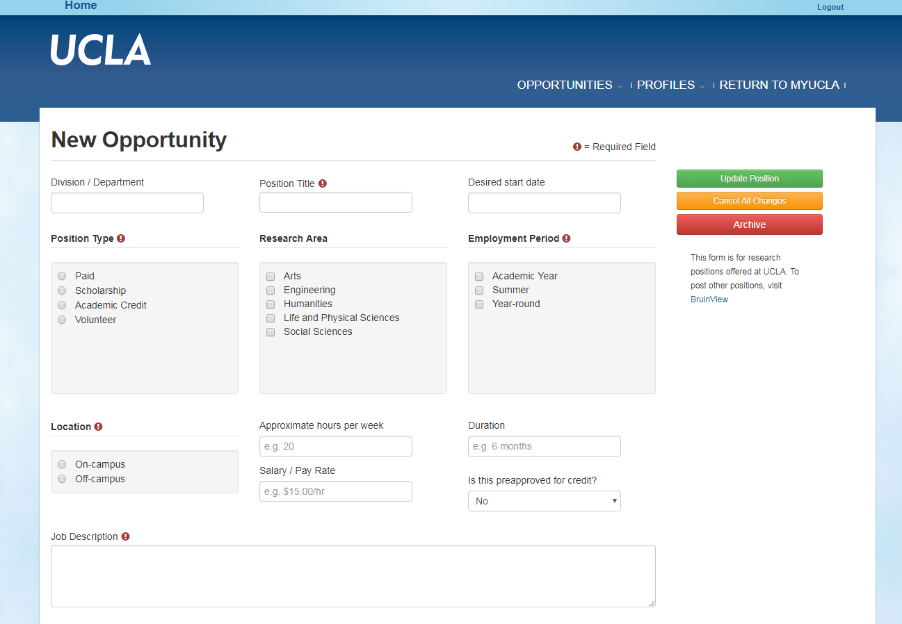

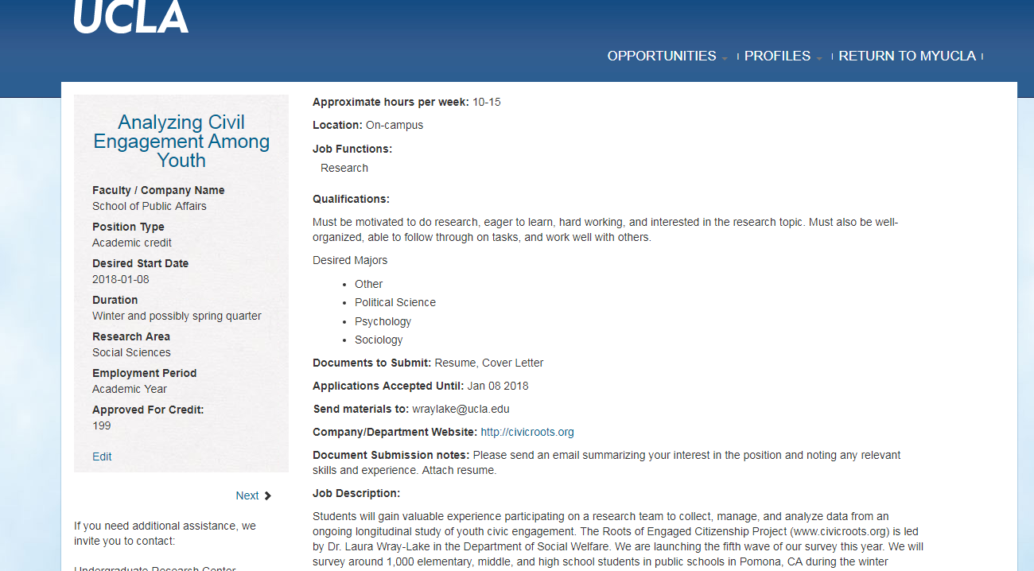

1. Once saved, you should be able to view your post.
2. Fill in the required information.
3. Select “Update Position” to save and make the opportunity public.

**Helpful Tips & Information**

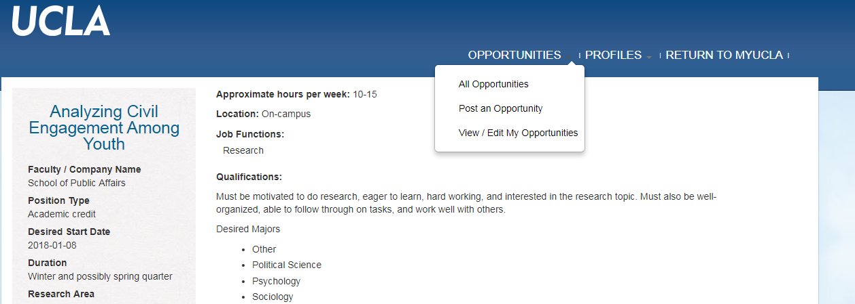

**Making edits:**

* To edit any post, select “View/ Edit My Opportunities” from the “Opportunities” menu on the upper right.

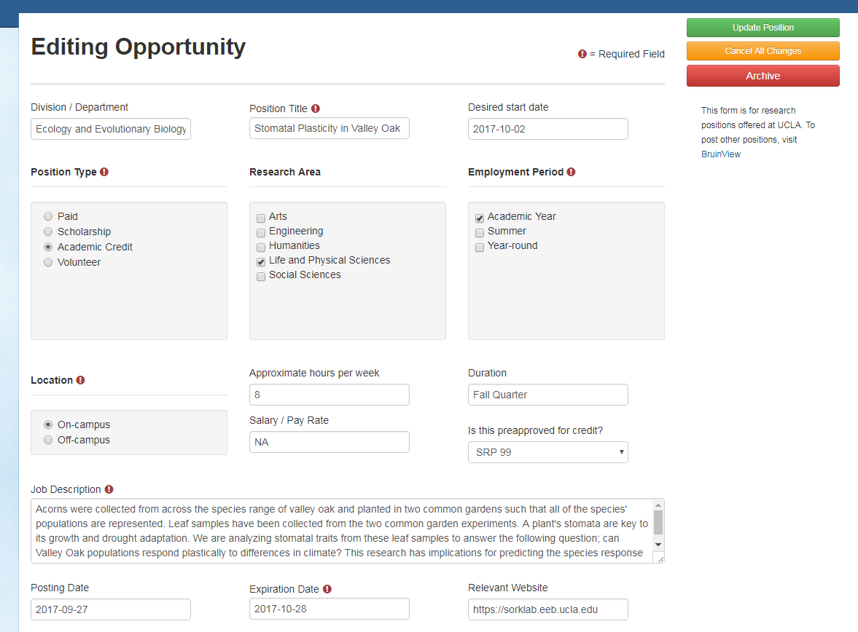

**Tip:**

* Give your position a distinctive to help it stand out.

**Archiving:**

* A post cannot be deleted, but can be archived.
* Archiving a position removes a post from view in the portal, but saves the information so that you retain access to it.

**Expiration Date:**

* When your posted opportunity is about to expire, you will be sent a notification.